

***Provider Directory FAQ***

Provider directories are known to be inconsistent, inaccurate and limited in the amount of information that is provided to members as they make choices about their care. Health plans are now required to improve directory data accuracy and information in order to provide members with the tools they need to make informed decisions. Benefits of the new solution include:

* A single portal for providers to maintain timely and accurate information.
* Consistent data allowing all health plans to access the same information.
* Regulatory requirements will be met for Centers for Medicare and Medicaid as well as the Massachusetts Division of Insurance.

***What are the benefits of this provider directory solution?***

Healthcare providers will now be able to submit and update their information in one portal rather than sending information to each health plan separately. Key benefits include the following:

* Improve the experience of members who rely on directories to select and contact providers.
* Enable providers to update their demographic information with multiple health plans in a streamlined way.
* Support timely, efficient directory updates.

***Who is participating in the program?***

  **[http://www.hcasma.org/images/fallon-health-webNEW.png](http://www.fchp.org/)**

[Health New England](http://healthnewengland.org/public) 

**[http://www.hcasma.org/images/TuftsHealthPlan_Logo_SiteUse.jpg](http://www.tuftshealthplan.com/)** **[http://www.hcasma.org/images/hphc_logo.gif](http://www.harvardpilgrim.org/)**

* CAQH, our existing single source vendor for credentialing information through their CAQH Provider Data Portal.
* Providers who submit information to health plans for use in provider directories.

***Directory Management***

CAQH Directory Management (formerly DirectAssure) is a directory module within their existing portal. Access to the directory information is through the portal.

***What are providers expected to do and how is this being communicated?***

Providers will be asked to update and confirm their directory data in the CAQH directory solution within the CAQH Provider Data Portal. This enables providers to submit professional and practice information and share it with multiple health plans, streamlining the data submission process for providers. This work will be essential to ensure that consumers have accurate and current information to access providers for patient care. Providers will be expected to do the following:

* Learn how the program works through communications from CAQH and health plans.
* When a provider is added to this process, review, correct and update information in the provider data portal.
* Validate information is correct by attesting to the accuracy of the information.
* Update directory data as changes occur to keep the information current.
* Revalidate data every 90 days from the last attestation period to indicate the data is still current.

HCAS health plans will provide ongoing communications regarding their specific directory updates.

***How does the program work?***

* Health Plans build interoperability with CAQH allowing them to upload existing demographic

information.

* As each health plan builds interoperability it will work with its provider organizations and begin to add those providers into CAQH Directory Management through the provider data portal.
* As providers are added, they will be notified by CAQH to enter the provider data portal as they do for credentialing.
* Once in the provider data portal, the provider will be prompted to review, add, correct and validate their information.
* Once validated, the data can be accessed by the health plan(s) who are actively using the system.
* Once all health plans have fully phased in use of the system, the program will become the single source for demographic information for health plan provider directories.

***What is the health plan directory data upload process to CAQH and how will it impact providers?***

Within the Directory Management workflow, health plans send provider Practice Location directory data to Directory Management every month.  Directory Management compares the health plan practice location data with provider self-attested data that already exists within CAQH Provider Data Portal. Practice locations that have not been previously attested to, which are new to a provider’s profile, are presented to the provider upon their login to CAQH Provider Data Portal.  Providers are then prompted for a decision regarding each practice location. Locations that are “Accepted” require additional data entry to be completed. “Rejected” locations will appear in the practice locations table as an “Archived and Rejected Location” and can be “Restored”. If a Provider selects ‘I don’t know’ they will be prompted to answer this question the next time they login.  There are no updates to existing data with a response of  “I don’t know”.

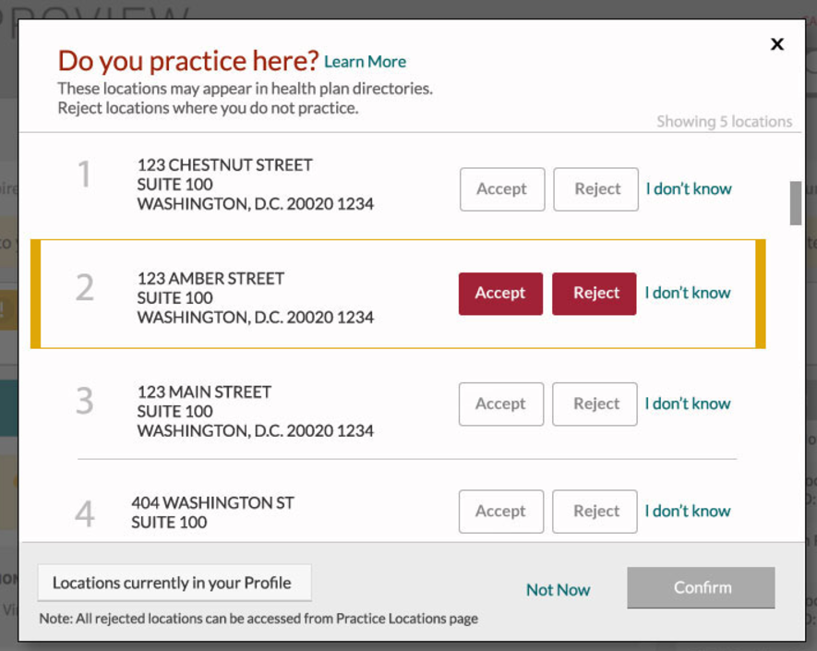

***What information will providers be asked to review and update?***

Providers will be asked to review and update the following information, including, but not limited to:

* Provider office locations, addresses, and phone numbers
* Institutional affiliations
* Specialty
* Open or closed panel status
* Languages spoken
* Accommodations for disabilities
* Accessibility information for each practice location
* Confirmation of completion of cultural competency training
* Behavioral health clinical areas of interest

***What information will providers need to send directly to each health plan?***

* Any time providers add or change an affiliation, contractual documents need to be sent directly to each health plan with whom the provider has a relationship
* An HCAS Enrollment form for a new provider joining a health plan
* W9 forms
* Other forms related to contractual or billing information

Please contact your health plan for additional information.

***How often do providers need to confirm and/or update their directory information?***

Providers must update their directory information any time there is a change, i.e., phone number, address, panel status. Additionally, providers will be asked to confirm their directory information no less frequently than every ninety **(90)** days to confirm that the data is still accurate. All required fields will need to be completed or updated prior to attestation.

***How will I receive notifications to update and confirm my directory information?***

Notifications will be sent to your primary method of contact email address listed in the CAQH Provider Data Portal.  If you have a designated contact, such as a credentialing specialist or practice manager listed as your primary email, please make that person aware of the importance of maintaining provider directory data updates within CAQH. **Please be sure to update and verify you have the correct contact information listed so that you can receive these important notifications**.

***What if I don’t have all the information available to complete the session, can I still attest?***

All required fields will need to be completed prior to attestation. There is the ability to save your data entries and complete your attestation upon your next login. **Please Note:** until attestation of the application is complete in the Provider Data Portal, it will not be communicated back to the health plans and they will not be able to access this information.

***What should I do if I see two practice locations for the same address?***

If you see more than one practice location listed for the same address it may indicate a duplicate record. Multiple variations of a practice location may appear in a provider’s profile when similar addresses are entered with a variance in Address Line 2. USPS Standardization will treat the variance in Address Line 2 as a separate physical practice location (i.e. suite number variance, floor number, department number, etc.). Please review the record for inconsistencies.

If the addresses are the same, we recommend that providers archive one of the locations using the reason code ‘This is a duplicate of an existing location’ (see screen shot below) so that the provider does not have two of the same locations on file:

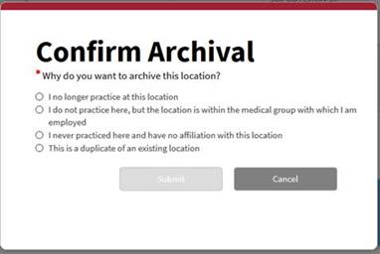

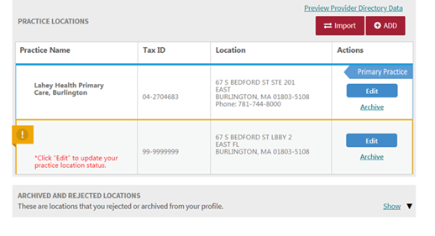

***Do I need to enter a suite number for practice addresses?***

Entering and maintaining accurate practice address information is essential. CMS has informed health plans that a valid suite number is required for a location address to meet federal requirements, therefore, all provider locations that have office suites should enter this information in CAQH. Address2/Suite numbers are entered or edited under the Practice Location section.

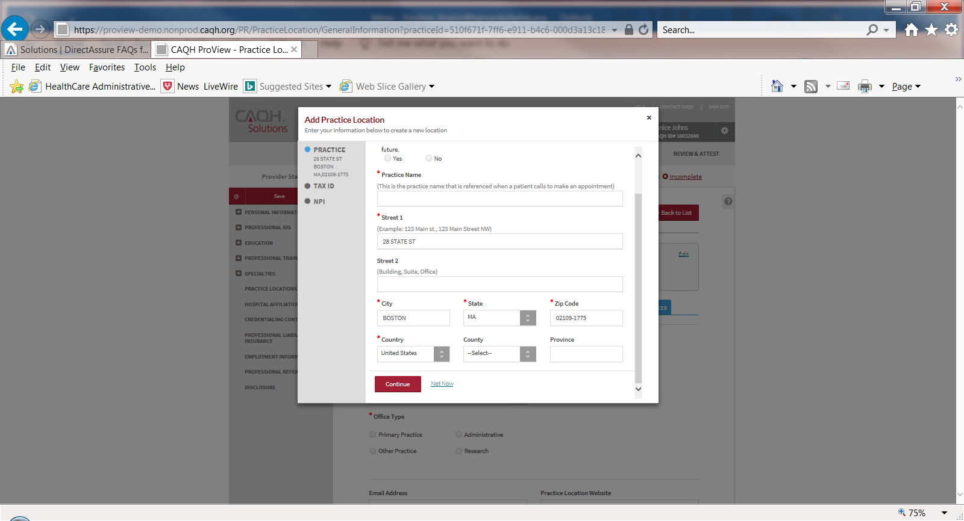

***What improvements are being made to help large provider organizations?***

HCAS and its member health plans worked with CAQH to develop a data submission process to enable large organizations to submit demographic information for multiple providers through a data upload process. To achieve this goal, the following three functionalities were added to the system:

* A directory data upload process to allow a file to be submitted to CAQH by an organization with multiple provider records.
* Multiple users may receive access to one provider record to accommodate either multiple people in one office or multiple offices to submit data on behalf of one provider.
* Validation/verification when uploading multiple providers at one time, allowing the uploaded data to be the “source of truth” for this information and not requiring each record to be validated one by one after data upload.

Directory data should be updated as changes occur. It is important to keep data as current as possible since accuracy of information is critical for this effort. Providers will be notified when this new functionality is available and provider organizations will be asked to utilize this process to streamline data submission for larger organizations.

***Some providers who have multiple affiliations have had difficulty sharing usernames and passwords for provider record access today. How is CAQH addressing this?***

CAQH has worked to develop the ability for the Provider Data Portal to allow for multiple users to have secured access to one provider record. HCAS and health plans will communicate additional information as it becomes available.

***How will behavioral health (BH) providers be impacted?***

Behavioral health providers will be included for those health plans that include them in their networks (carve-in). For health plans that do not include BH providers in their networks (carve-outs), BH providers should follow the process as defined by their managed BH organization for updating information unless directed otherwise. BH providers will be asked to identify specific conditions that they treat and by age limitation as required by state regulatory requirements. **Important note:** this is directory information only. Any contract information must continue to be sent to the health plan(s).

***How do I update my directory information in the CAQH Provider Data Portal?***

Once you have been added to the directory program by any of the health plans:

* Log in to the CAQH Provider Data Portal by entering your username and password.
* On the Attestation page, follow these three steps:
  1. Click the link to view your Provider Directory Snapshot. If any data is incorrect, click X (in the upper right-hand corner) to close the snapshot and make changes within your profile.
  2. Click Verify Review once you have made updates or if no changes are needed.
  3. Indicate that you have reviewed your Provider Directory Snapshot and then click Attest.
* The Attestation Complete screen will appear, and you will receive a confirmation email.

***What tools and resources are available if I need assistance?***

To learn more please visit the following websites for the latest training videos, announcements and directory information**:**

<http://www.hcasma.org/Directory.htm>

<https://www.caqh.org/solutions/provider-data/directory-management>

Providers or Practice Managers who require assistance using the Provider Data Portal may utilize a Virtual Assistant that was added to the Chat Support functionality or contact the CAQH helpdesk:

**CAQH Help Desk**

[login [proview.caqh.org]](https://urldefense.com/v3/__https:/proview.caqh.org/Login/Index__;!!BXZ_7oASwFcAgTU!ng7IXN7IJta3CGJz0ydKzNm8MMQ02253oWhveJ32nLUNogJbKgdUfpquI0_6HCI2WBzL2x15KhSNJ_1ysn7lXuHkOOBuTsQ$) and click the chat icon or call 888-599-1771